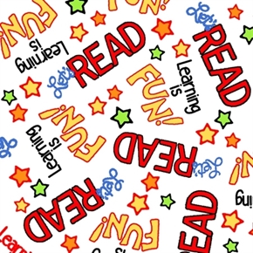

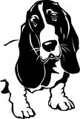

**Kidz Klub**

**Today at**

**NDOG Kidz Klub**

**Interactive Reading**

**and Activity**

**Today Betsy Falcon will lead an interactive reading of this enchanting story about finding and using your special talents.**

